User Manual for VNA Test Bench Type-B

|  |  |  |  |
| --- | --- | --- | --- |
|  |  | | |
|  | Prepared By:  KPIT Technologies Ltd.  Vehicle Network E&E Architecture  Pune, India  CONFIG ID : R.0035239.001  VERSION : 1.0  DATE : 05-Sep-24  Prepared For:  Honda Motors  E&E Network Architecture  Tochigi, Japan | | |
|  |  |  |  |
|  |
|  |
|  |  | | |

Revision History

|  |  |  |  |  |
| --- | --- | --- | --- | --- |
| Ver. | Change Description | Approved By | Prepared/  Modified By | Date of Approval |
| 1.0 | Initial version | Nitin Ambupe | Suraj Sutar | 5-Sep-24 |
|  |  |  |  |  |
|  |  |  |  |  |
|  |  |  |  |  |

Contents

1.Introduction 8

1.1 About this document 8

1.2 Safety & Security 8

1.3 Warranty and Safety Information 9

2. Schematic: Design from OEM architecture 10

2.1 GEN3 E&E network architecture 10

2.1.1 Architecture study of ECUs 10

2.1.2 Buses connected to ECUs 11

2.1.3 Ethernet Switches 11

2.2 High level block diagram 11

2.3 Schematic 13

3. Test Bench Type-B 16

3.1 Front side 16

3.1.1 Real ECU Core Front Center Tel 16

3.1.2 Ethernet Switch RJ45 (Stimulation) 16

3.1.3 Testing PC 17

3.2 Right & Left side 17

3.3 Back side 18

3.3.1 CM 1000 High H-MTD 19

3.3.2 Ethernet Switch RJ45 (Logging) 19

3.3.3 CM CAN Combo 19

3.3.4 CM CAN wiring 20

3.3.5 CAN channels connections to Real ECU 20

3.3.6 Power supply wiring 21

3.4 IP setting on CAN modules 22

3.5 RJ45 Connections 23

3.5.1 CAN (LOG & STIM) to EES connections. 23

3.5.2 Netgear switch connections to host ports of all modules 24

3.6 CM 1000 High HMTD connections 25

3.7 Test bench readiness 25

3.7.1 Physical Validation of connections 25

3.7.2 Test bench power ON 27

3.8 Validation checklist 27

4. Test bench configuration 28

4.1 Flashing of firmware 28

4.2 License updates CAN 28

4.3 Web interface configuration 29

4.3.1 EES 29

4.3.2 CAN (LOG & STIM) 30

4.3.3 CM 1000 HMTD 33

4.4 Validation checklist 35

5. Test bench troubleshooting 36

6. Maintenance 37

6.1 Support for Test bench TYPE-B 37

7. Reference documents 37

**LIST OF FIGURES**

Figure 1 E&E Network Architecture PADAS Hands-off 10

Figure 2 High level block diagram 12

Figure 3 Test bench Schematic Back view 13

Figure 4 Test bench Schematic Front view 14

Figure 5 Real photo of the front view of the test 16

Figure 6 Right & Left view 17

Figure 7 Real photo of the back view of the test 18

Figure 8 Real photo of the CAN wiring of the test 20

Figure 9 Real photo of test bench CAN channels to real ecu 20

Figure 10 Power supply wiring for CM CAN, CM 1000 HMTD 21

Figure 11 Power supply wiring for Ethernet Switch 21

Figure 12 IP config switch 22

Figure 13 Ethernet switch RJ45 (Logging) 23

Figure 14 Ethernet switch RJ45 (Stimulation) 23

Figure 15 Netgear switch connections 24

Figure 16 CM 1000 High connections 25

Figure 17 ECU Power supply PT4 connector 26

Figure 18 Measurement Power supply pt4 connector 26

Figure 19 Unlicensed CAN transmission 28

Figure 20 Licensed CAN transmission 28

Figure 21 EES IP configuration web view 29

Figure 22 EES license web view 29

Figure 23 CM CAN System information web configuration view 30

Figure 24 CM CAN GBA port web configuration view 31

Figure 25 CM CAN channel web configuration view 32

Figure 26 CM 1000 high HMTD system information view 33

Figure 27 CM 1000 high HMTD GB-B web configuration view 34

Figure 28 CM 1000 high HMTD B channel web configuration view 34

Figure 29 CM 1000 high HMTD A channel web configuration view 35

**LIST OF TABLES**

Table 1 Acronyms & Abbreviations 7

Table 2 Warranty and safety details 9

Table 3 Buses connected to ECUs 11

Table 4 Schematic - modules on back side 13

Table 5 Schematic modules of Front side 14

Table 6 Generic Schematic modules of Front side 15

Table 7 CAN combo at right side of test bench 17

Table 8 CAN combo at left side of test bench 18

Table 9 CAN combo at back side of test bench 19

Table 10 Power supply details 26

Table 11 Test bench troubleshooting steps 36

Table 12 Reference documents 37

**ACRONYMS AND ABBREVIATIONS**

|  |  |
| --- | --- |
| **Acronym** | **Definition** |
| EES | Enhanced Ethernet Switch |
| CM CAN | Capture Module CAN |
| CM 1000 HMTD | Capture Module 1000 HMTD |
| LOG | Logging |
| STIM | Stimulation |
| TYPE-B | Test bench with real ECU |

Table 1 Acronyms & Abbreviations

# 1.Introduction

## 1.1 About this document

This user manual contains valuable information for the proper and safe operation of the HONDA test bench Type-B. This document is created based on Honda Gen-3 E&E PADAS-OFF architecture. Read this user manual carefully before use.

## 1.2 Safety & Security

Technica Engineering products are designed for operation in automotive systems and supply voltages of nominal 12 V or 24 V. The voltage limit for the integrated test PC is 100 V to 240V AC.

Technica Engineering products to be operated in voltage ranges beyond those specified in the norms, which represents a breach of the conditions of operation, then this will void the product warranty and Technica Engineering will assume no liability whatsoever for the results and/or consequences thereof.

This is especially valid whenever the voltage level reaches or exceeds the limits of the low voltage directive. In this case, damage to the devices cannot be excluded. Due to the manufacturing characteristics of the devices, there is no imminent fire hazard from the device itself, if the devices are being operated in an environment according to the conditions of use. A secondary fire hazard cannot be excluded, should those conditions not be met. Protection against overvoltage cannot be provided in such a breach of the conditions of use.

## 1.3 Warranty and Safety Information

|  |  |
| --- | --- |
|  | Read this manual before using test bench. |
|  | Use the test bench only as described in this manual.  Use only in dry conditions.  Do not insert any foreign object in the slots/openings of the housing.  Do not apply power to a damaged device.  The test bench is to be used only by specialists. |
|  | Do not open the test bench or parts of the bench. Otherwise, the warranty will be lost. |
| https://proxy.duckduckgo.com/iu/?u=https%3A%2F%2Ftse1.mm.bing.net%2Fth%3Fid%3DOIP.HMnzwZ5PFiL_IZxaDSm-rQHaHa%26pid%3D15.1&f=1 | Do not cover the test bench due to fire danger.  Do not place the test bench near highly flammable materials due to fire danger.  Do not use the devices inside the test bench above the specified operating temperatures.  The operating temperature is the ambient temperature of the installation space. |

Table Warranty and safety details

# 2. Schematic: Design from OEM architecture

*

The first step while building the test bench is to carefully study the applicable E&E architecture, derive the number of DUTs to be placed on the bench, applicable In-Vehicle Network communication technologies and future test scenarios or test use cases. Following sections briefly describe the approach and steps to design the schematic.

## 2.1 GEN3 E&E network architecture

Please note that the content of this user manual is applicable to Type-B test bench for Honda Gen3 E&E Hands-off network architecture.

### 2.1.1 Architecture study of ECUs

Identify the number of zonal ECUs connecting different vehicular domain present in architecture as shown in following figure.

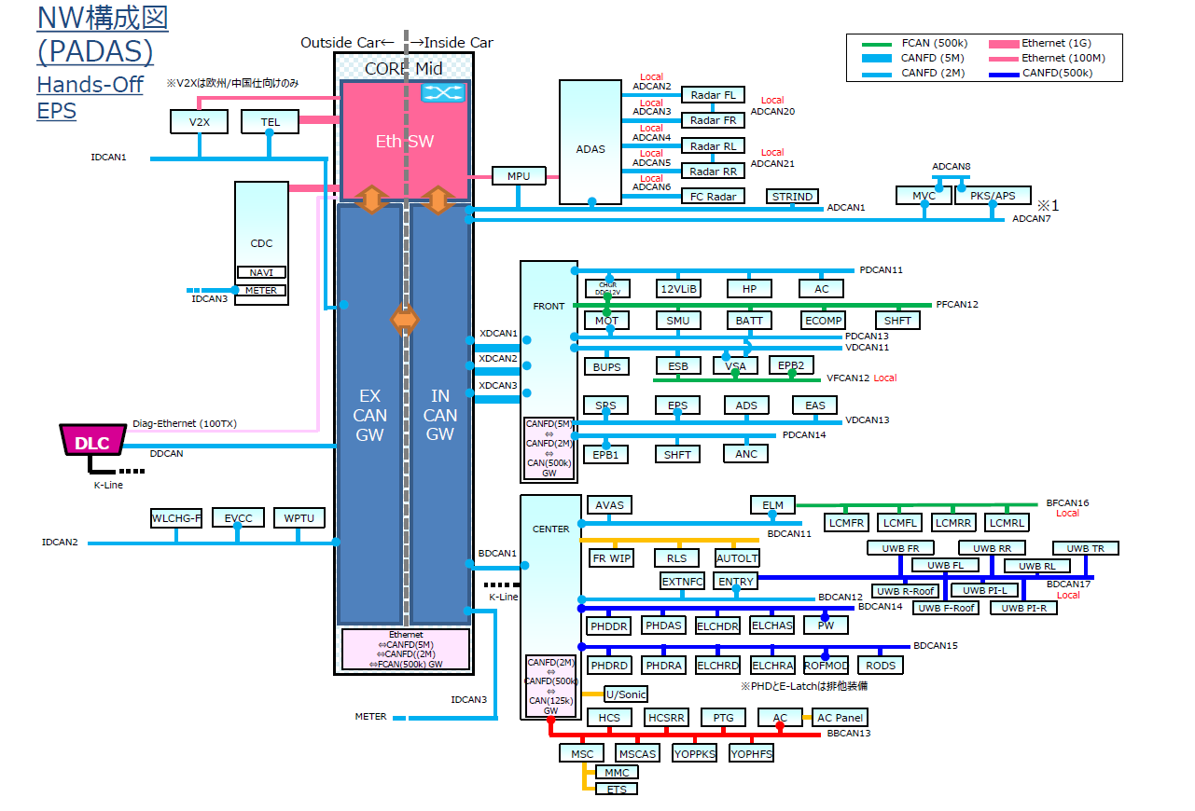

Figure 1 E&E Network Architecture PADAS Hands-off

As per the above architecture there are 7 ECU e.g.: CORE, ADAS, FRONT, CENER, CDC, V2X, TEL Etc.

### 2.1.2 ECUs and Connected communication channels

|  |  |
| --- | --- |
| **ECU** | **CAN Buses** |
| CORE | XDCAN1, XDCAN2, XDCAN3, BDCAN1, ADCAN7, ADCAN1, IDCAN1, IDCAN2, IDCAN3, DDCAN |
| ADAS | ADCAN2, ADCAN3, ADCAN4, ADCAN5, ADCAN6 |
| FRONT | PDCAN11, PFCAN12, PDCAN13, PDCAN14, VDCAN11, VDCAN13, VFCAN12 |
| CENTER | BDCAN11, BDCAN12, BBCAN13, BDCAN14, BDCAN15, BFCAN16, BDCAN17 |

Table 3 Buses connected to ECUs

The mentioned CAN bus channels are crucial for connecting to the ECU. This information aids in determining the required number of CAN channels to simulate for the network nodes.

### 2.1.3 Ethernet Switches

The Ethernet buses within the architecture are linked to the Eth SW, assisting in identifying the necessary count of Ethernet channels required, and mapping them to measurement and capture device - the EES automotive Ethernet.

## 2.2 High level block diagram

A comprehension of the architecture will facilitate the development of a block diagram.

Subsequently, this block diagram becomes instrumental in the creation of the schematic.

Refer below high-level block diagram derived from Figure 2 High level block

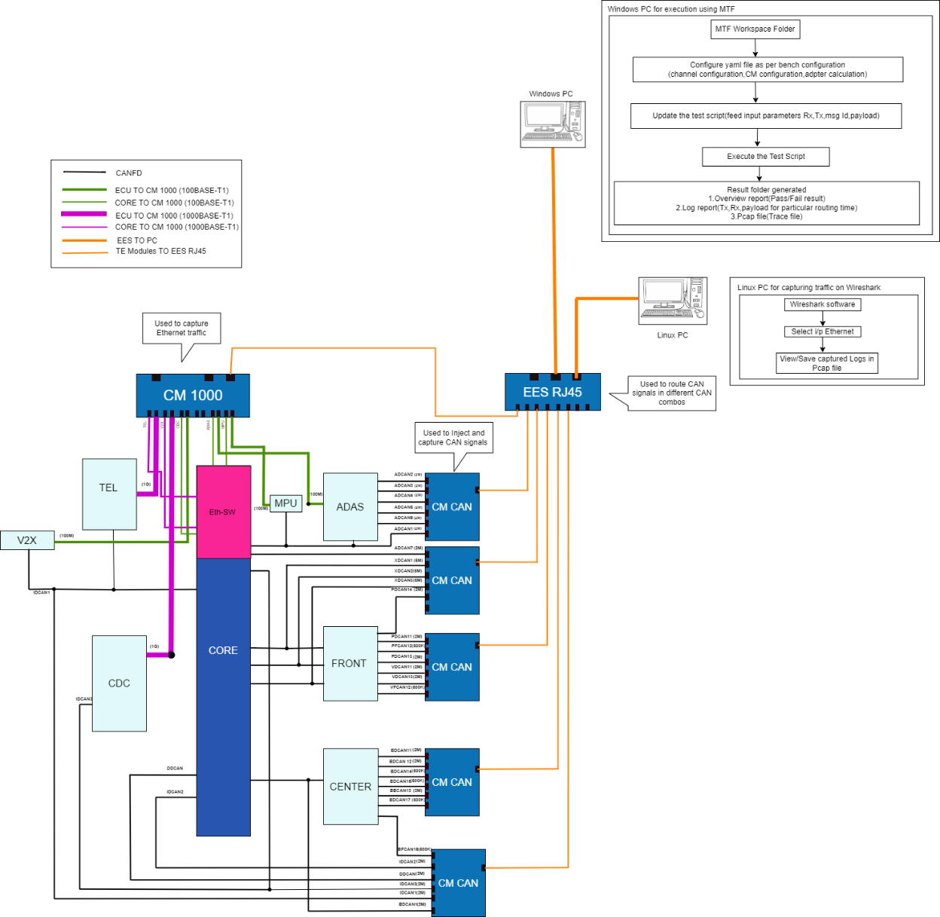

Figure 2 High level block diagram

This block diagram serves as a visual depiction of connection of Technica modules within E&E architecture, while the schematic provides a more detailed breakdown of this connection.

## 2.3 Schematic

Figure 3 Test bench Schematic Back view

1. As per the above schematic, Bill of Material is derived to identify the required quality of each measurement and capture devices – to simulate and log the network communication.

|  |  |  |
| --- | --- | --- |
| **Sr No** | **Part Description** | **Quantity** |
| 1 | Enhanced Ethernet Switch RJ-45 Variant- (Logging) | 1 |
| 2 | CM CAN Combo HW 3.3 (Logging) | 6 |
| 3 | CM CAN Combo HW 3.3 (Stimulation) | 6 |
| 4 | CM 1000 High H-MTD HW 5.1 | 1 |

Table 4 Schematic - modules on back side

1. Similarly, the front side of the schematic is referred to identify the required quantity of each of measurement and capture devices - has been created for “Front view.”
2. Please refer below Figure 4 Test bench Schematic Front view
3. A computer screen shot of a computer

   Description automatically generated

Figure 4 Test bench Schematic Front view

|  |  |  |
| --- | --- | --- |
| **Sr No** | **Part Description** | **Quantity** |
| 5 | EES RJ-45 Variant (Stimulation) | 1 |
| 6 | Real CORE ECU | 1 |
| 7 | Real ADAS ECU | 1 |
| 8 | Real CENTER ECU | 1 |
| 9 | Real FRONT ECU | 1 |
| 10 | Real TEL ECU | 1 |
| 11 | Real CDC ECU | 1 |
| 12 | Real V2X ECU | 1 |
| 13 | Netgear switch | 1 |

Table 5 Schematic modules of Front side

1. Additionally, to be able to provide power up the required devices and to access & configure, the following components have been identified and connected to the test bench.

|  |  |  |
| --- | --- | --- |
| **Sr No** | **Part Description** | **Quantity** |
| 14 | Programmable Power supply TDK-GENH20-38-D (All Technica devices) | 1 |
| 15 | Programmable Power supply TDK-Z20-20-LAN-L-J  (Real ECU) | 1 |
| 16 | Windows Desktop | 1 |
| 17 | LINUX Desktop | 1 |
| 18 | Test bench Mechanical structure | 1 |

Table 6 Generic Schematic modules of Front side

# 3. Test Bench Type-B

Test bench Type-B represents the Vehicle network architecture test bench which consists of Real ECUs integrated with various Technica capture modules and ethernet switches to cover all communications protocol in EE architecture.

## 3.1 Front side

The front section of the bench is equipped with multiple devices, allowing users to interact with PCs to test various ECU.

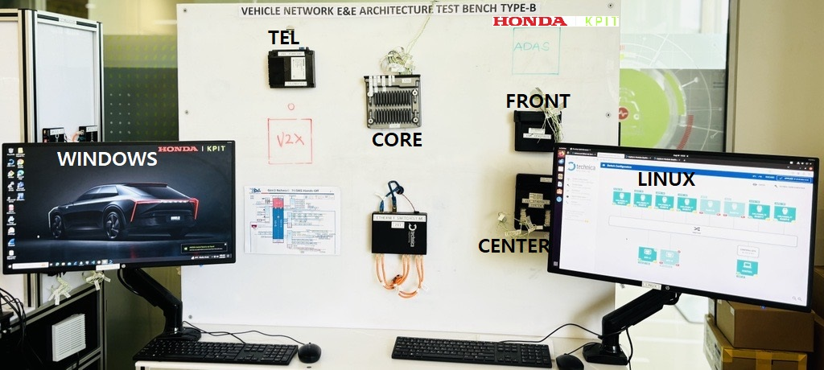

Figure 5 Real photo of the front view of the test

### 3.1.1 Real ECUs (DUTs)

The front side of the test bench consists of all real ECUs from Honda.

Test bench is currently integrated with CORE, FRONT and subsequently, rest of the ECUs will be integrated.

### 3.1.2 Ethernet Switch RJ45 (Stimulation)

This Ethernet switch is dedicated to connecting the CAN capture modules which are used for rest bus stimulation of ECU(s) messages part of the E&E architecture. The intended messages from the test script hosted and executed from Test PC will be routed by the EES switch to CAN capture modules and then subsequently sent on to the CAN bus.

### 3.1.3 Test PC

This Test bench consists of two high configuration test PCs with Windows and Linus operating systems, respectively. Windows test PC is to be used for Test executions and Test report generation, and Linux desktop is to be used for monitoring the traffic logs on Wireshark. Linux test PC can also be used for Web configurations of all devices and test activities specific to Layer 2 and Layer 3 as dependent libraries can be installed and used on Linux platform only.

## 3.2 Right & Left side

The right section & left section of the test bench are responsible for rest bus simulation and inject CAN traffic on CAN bus of the Network architecture as per ARXML.

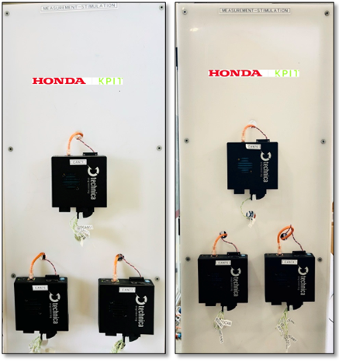

Figure 6 Right & Left view

The **CM CAN Combo** is an active tap device that is used to capture traffic from conventional CAN buses, as well as CAN-FD, Flex Ray, and RS-232. The traffic is captured without causing interference on the network and is delivered with a 40 ns resolution hardware time stamp.

Right side of test bench:

|  |  |
| --- | --- |
| CM CAN 71 | PDCAN11, PFCAN12, PDCAN13, VDCAN11, VDCAN13 |
| CM CAN 76 | ADCAN2, ADCAN3, ADCAN4, ADCAN5, ADCAN6 |
| CM CAN 77 | BDCAN11, BDCAN12, BBCAN13, BDCAN14, BDCAN15 |

Table 7 CAN combo at right side of test bench

Left side of test bench:

|  |  |
| --- | --- |
| CM CAN 70 | BFCAN16, BDCAN17 |
| CM CAN 74 | XDCAN1, XDCAN2, XDCAN3, IDCAN3, ADCAN7, ADCAN1 |
| CM CAN 75 | BDCAN1, IDCAN2, IDCAN1 |

Table 8 CAN combo at left side of test bench

## 3.3 Back side

The back section of the test bench is dedicated to installing devices for logging CAN & Ethernet traffic from the E&E network.

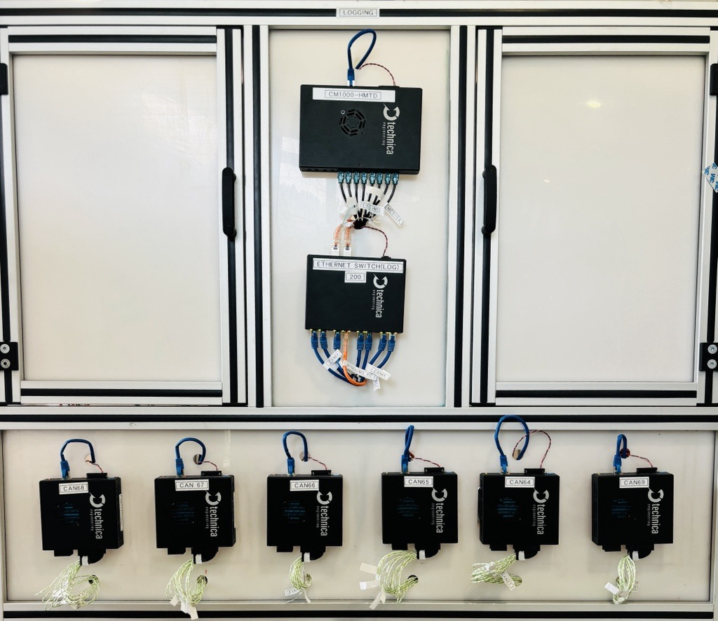

Figure 7 Real photo of the back view of the test

### 

### 3.3.1 CM 1000 High H-MTD

This is an active tap device that is used to capture traffic from 6 automotive ethernet buses and up to 6 point-to-point 100/1000BASE-T1 connections.

### 3.3.2 Ethernet Switch RJ45 (Logging)

This Ethernet switch is dedicated to connecting the CAN modules which are used for logging the CAN traffic in network.

### 3.3.3 CM CAN Combo

This is an active tap device that is used to capture traffic from conventional CAN buses, as well as CAN-FD, Flex Ray, and RS-232. The traffic is captured without causing interference on the network and is delivered with a 40 ns resolution hardware time stamp.

|  |  |
| --- | --- |
| CM CAN 64 | XDCAN1, XDCAN2, XDCAN3, IDCAN3, ADCAN7, ADCAN1 |
| CM CAN 65 | BDCAN1, IDCAN2, IDCAN1, DDCAN |
| CM CAN 66 | ADCAN2, ADCAN3, ADCAN4, ADCAN5, ADCAN6 |
| CM CAN 67 | BDCAN11, BDCAN12, BBCAN13, BDCAN14, BDCAN15 |
| CM CAN 68 | PDCAN11, PFCAN12, PDCAN13, VDCAN11, VDCAN13 |
| CM CAN 69 | BFCAN16, BDCAN17 |

Table 9 CAN combo at back side of test bench

### 3.3.4 CM CAN wiring

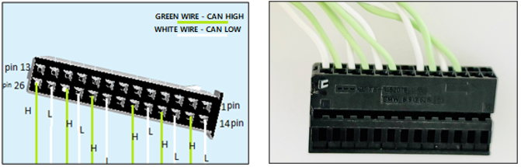

Figure 8 Real photo of the CAN wiring of the test

This is the CAN wiring done for the Test bench, pin no. 14 is CAN LOW and pin no. 15 is CAN HIGH.

Note: Kindly do not connect any wire to pin no. 7 and pin no. 20, as they are dedicated for bus termination resistance.

### 3.3.5 CAN channels connections to Real ECU

Figure 9 Real photo of test bench CAN channels to real ecu

The above image is of a switch box which is used to interconnect the ECU’s CAN channel ports to the corresponding ports of the CAN Capture Module. The harnesses on the upper part connect to the DUT and lower part connect to the Capture module.

### 3.3.6 Power supply wiring

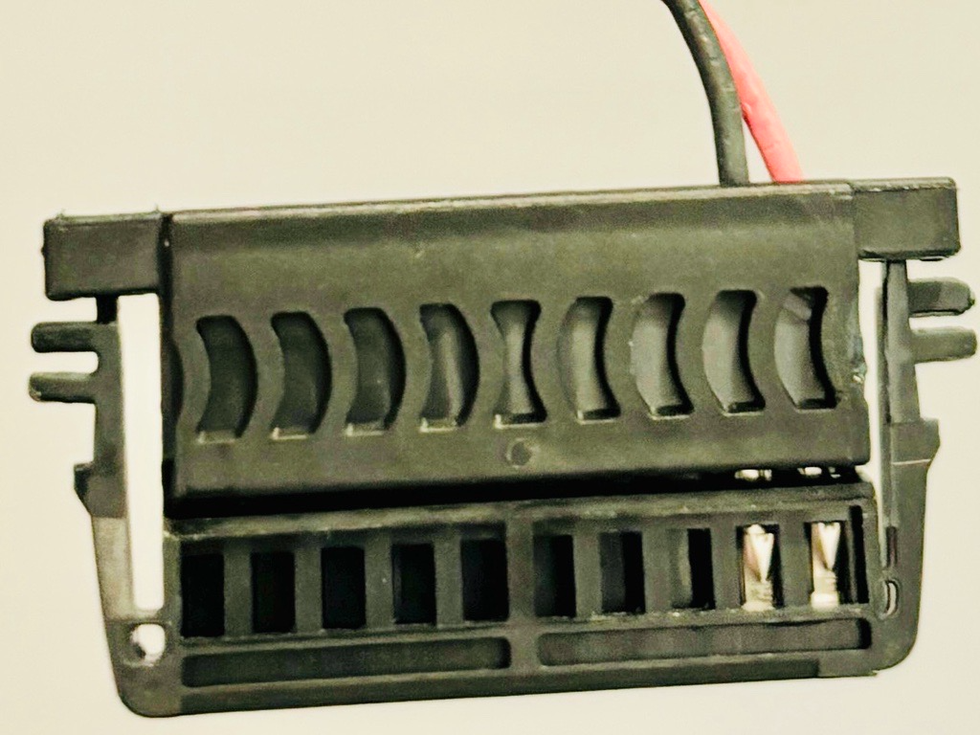

Figure 10 Power supply wiring for CM CAN, CM 1000 HMTD

Power supply wiring for all CM CAN & Cm 1000 must be done as per above image, incorrect wiring can damage the modules.

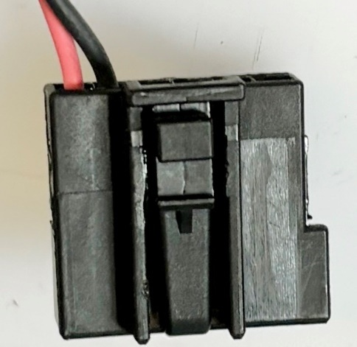

Figure 11 Power supply wiring for Ethernet Switch

Red harnesses are Voltage & Black wires are GND, all Technica modules supply voltages of nominal 12 V.

## 3.4 IP setting on CAN modules

Figure 12 IP config switch

By default, each CM CAN module is set to the IP address 10.104.3.64. To assign the IP address 10.104.3.65 to a CAN combo, adjusting the arrow point to “1” is necessary in the configuration process. Similarly, as below:

0: 10.104.3.64

1: 10.104.3.65

2: 10.104.3.66

3: 10.104.3.67

4: 10.104.3.68

5: 10.104.3.69

6: 10.104.3.70

7: 10.104.3.71

8: 10.104.3.72

9: 10.104.3.73

A: 10.104.3.74

B: 10.104.3.75

C: 10.104.3.76

D: 10.104.3.77

E: 10.104.3.78

F: 10.104.3.79

## 3.5 RJ45 Connections

### 3.5.1 CAN (LOG & STIM) to EES connections.

a) CM CAN(LOG) RJ45 are connected to EES (LOG) RJ45(10.104.3.200).

Figure 13 Ethernet switch RJ45 (Logging)

In the above figure, the CAN logging RJ45 are connected to EES ports.

F1(BASET-1): CM CAN 67 Logging.

F2(BASET-2): CM CAN 66 Logging.

F3(BASET-3): CM CAN 69 Logging.

F4(BASET-4): CM CAN 68 Logging.

F5(BASET-5): Test PC(Windows).

F6(BASET-6): CM 1000 HMTD.

F7(BASET-7): CM CAN 65 Logging.

F8(BASET-8): CM CAN 64 Logging.

b) CM CAN(STIM) RJ45 are connected to EES (STIM) RJ45(10.104.3.201).

Figure 14 Ethernet switch RJ45 (Stimulation)

In the above, the CAN STIM RJ45 are connected to EES ports as below.

F1(BASET-1): CM CAN 74 Stimulation.

F2(BASET-2): CM CAN 75 Stimulation.

F3(BASET-3): CM CAN 70 Stimulation.

F4(BASET-4): CM CAN 71 Stimulation.

F7(BASET-7): CM CAN 76 Stimulation.

F8(BASET-8): CM CAN 77 Stimulation.

### 3.5.2 Netgear switch connections to host ports of all modules

Netgear switch is used to connect all host ports from EES(LOG), EES(STIM), Test PC(Windows) & LINUX PC, as shown in below Figure 15.

This helps while configuring all modules on web interface at the start.

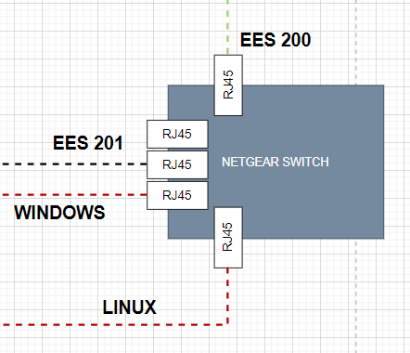

Figure 15 Netgear switch connections

## 3.6 CM 1000 High HMTD connections

Figure 16 CM 1000 High connections

In above Figure: 16 the CM 1000 High are connected to Real ECU as below.

1A00144: CORE to C 1000 High.

1B00144: CM 1000 High to TEL.

2A00144: CORE to CM 1000 High.

2B00144: CM 1000 High to CDC.

3A00144: CORE to CM 1000 High.

3B00144: CM 1000 High to V2x.

5A00144: CORE to CM 1000 High.

5B00144: CM 1000 High to ADAS.

## 3.7 Test bench readiness

### 3.7.1 Physical Validation of connections

Kindly refer the points below to verify the connections physically:

1. Check all power supply wire of PT4 connector, red must be connected to Voltage and black to Ground, also ECU power supply must be connected to ECUs, and all other Technica modules to power-up measurement devices, as show in below Figure: 17.

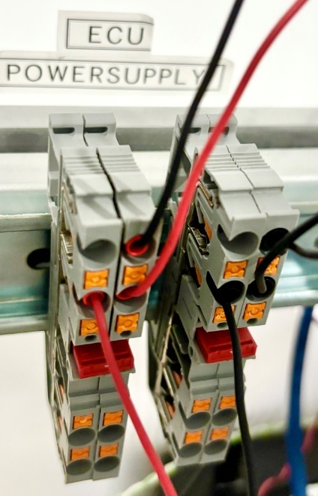

Figure 17 ECU Power supply PT4 connector

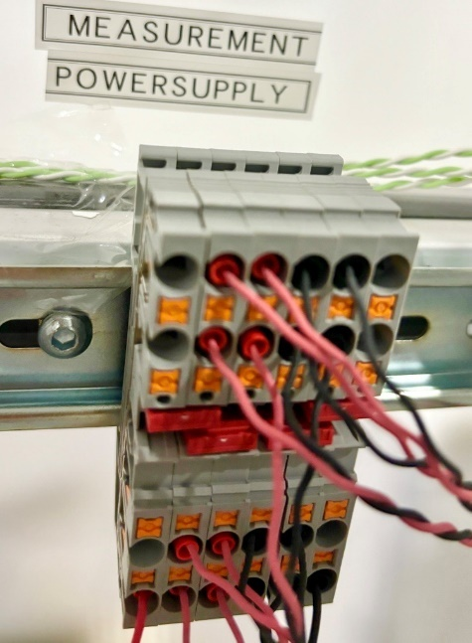

Figure 18 Measurement Power supply pt4 connector

1. Ensure that the power supply is provided as per the following table.

|  |  |  |  |
| --- | --- | --- | --- |
| Sr no. | Module | Voltage | Amp |
| 1 | Real ECU | 12-volt DC | 1 Amp /per module |
| 2 | Technica EES, CAN, CM 1000 modules | 12-to-24-volt DC | 0.5/per module |

Table 10 Power supply details

1. Check and ensure all CAN channel adapters are connected properly to CAN port.
2. Check and ensure all RJ45 is connected properly.
3. Check and ensure that there are No Open wires on and around the bench.

### 3.7.2 Test bench power ON

1. Turn On Main Power supply.
2. Turn On ECU power supply.

* Caution!! Turn off Power supply in case of any failed connection.

## 3.8 Validation checklist

* The wiring of CAN and Power supply is done and connected to correct ports.
* CAN combo for STIM & LOG are connected correctly as per schematic.
* Real ECU CAN channels and CM CAN (STIM & LOG) mapped correctly on PT4 connector.
* IP setting of all CM CAN combo done correctly.
* RJ45 connected properly for CM CAN, EES, Netgear switch.
* The CM 1000 high HMTD connection is correct.

# 4. Test bench configuration

## 4.1 Flashing of firmware

1. Each Technica module includes a firmware software interface that enables its functionality.
2. It is important to have the latest firmware present on the module, hence update the module with latest software.
3. The process involves initially updating the boot loader file followed by the firmware update.
4. You can request the latest firmware update by contacting [support@technica-engineering.de](mailto:support@technica-engineering.de). When reaching out, it is helpful to specify the current software version present on the module to ensure you receive the appropriate update.

## 4.2 License updates CAN

1. Updating the CAN transmission license on the CM CAN module is necessary to enable both transmission (Tx) and reception (Rx) of CAN signals. Below Figure: 19 shows that CAN transmission license is not present.

Figure 19 Unlicensed CAN transmission

1. After installation of license below changes can be seen as per Figure: 20

Figure 20 Licensed CAN transmission

1. With this installation CAN combo is ready to send and receive messages.

## 4.3 Web interface configuration

### 4.3.1 EES

1. As all Enhanced Ethernet Switches are by default set to the IP address 10.104.3.200, their configuration ports connected to the Netgear switch allow access to the web interface of all EES.
2. While configuring each EES you must change the IP address as per configuration, as shown below:
3. EES(LOG): 10.104.3.200
4. EES(STIM): 10.104.3.201
5. Apply configuration & save.

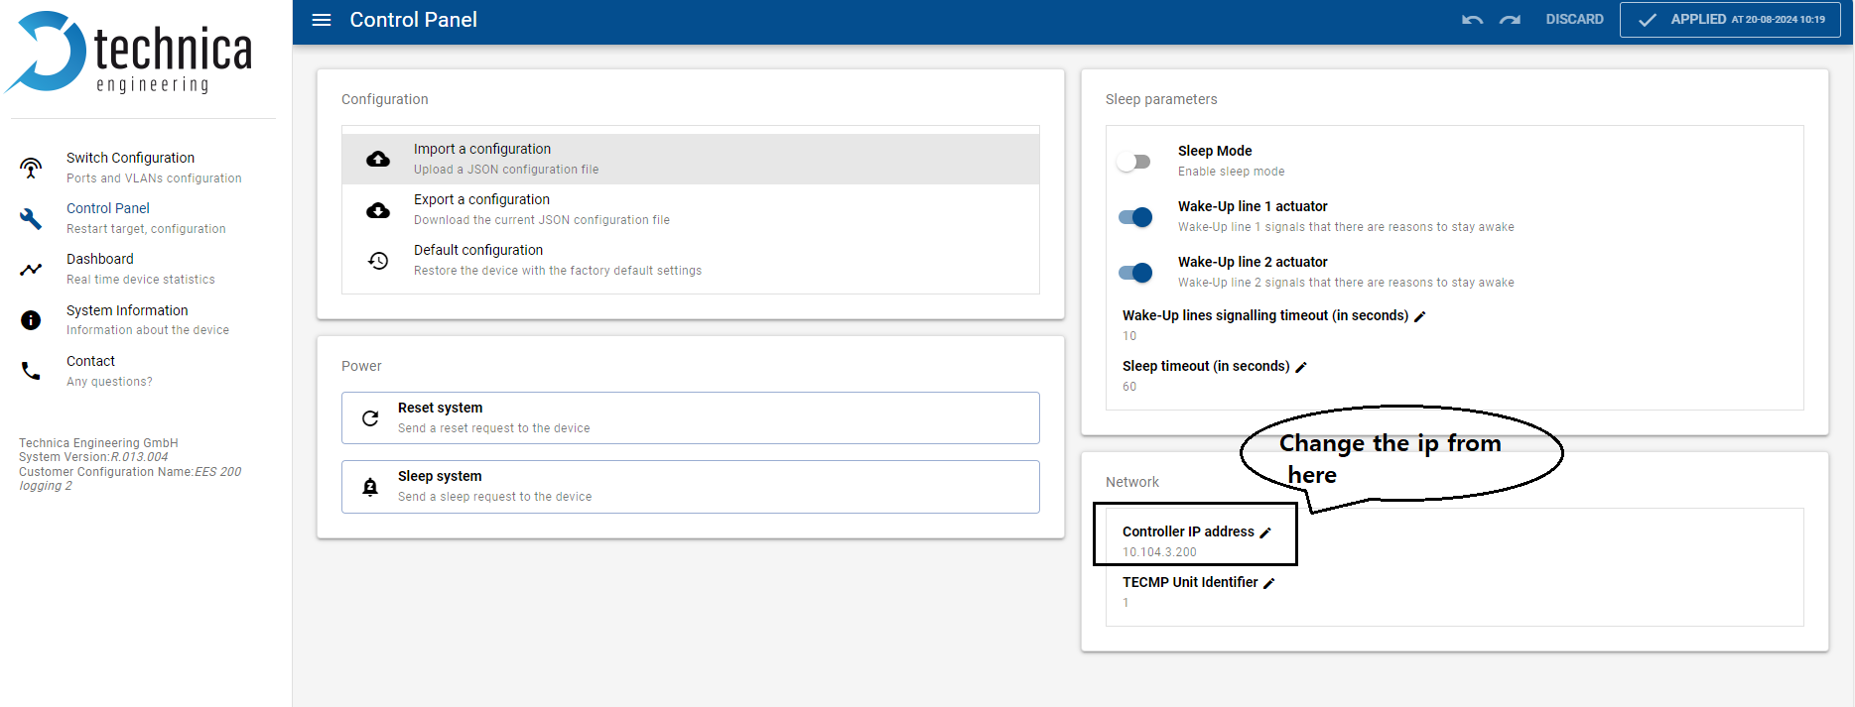

Figure 21 EES IP configuration web view

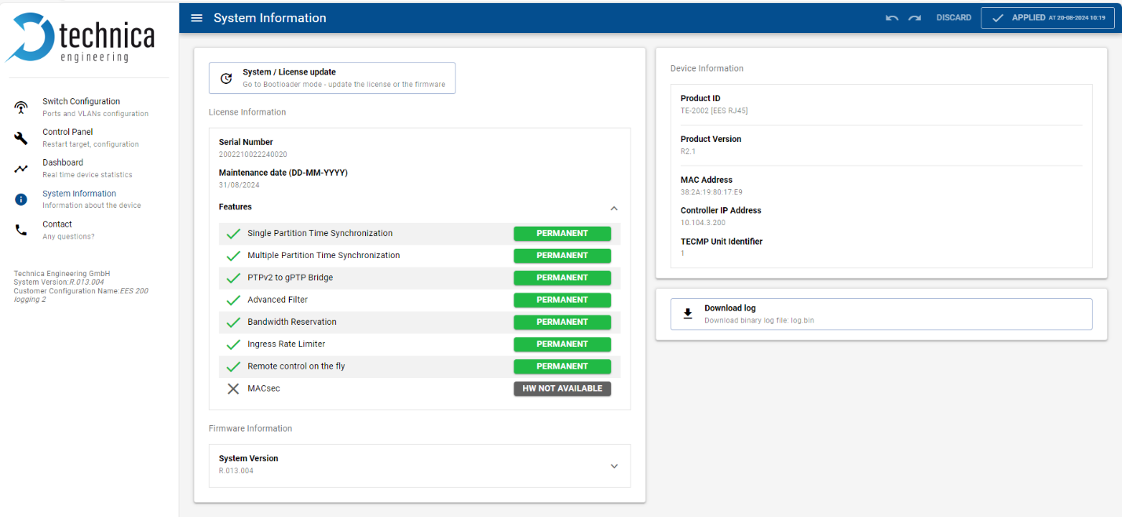

Figure 22 EES license web view

### 4.3.2 CAN (LOG & STIM)

1. All CAN for LOG & STIM should have latest firmware and transmission licenses enabled.

Figure 23 CM CAN System information web configuration view

1. Below are some standard configurations setting need to be done for CAN web interface.
2. CAN STIM (10.104.3.66)
3. GB-A:
4. 802.IAS mode à Slave
5. PTP mode à gPTP Automotive

please refer to the following figure for more information.

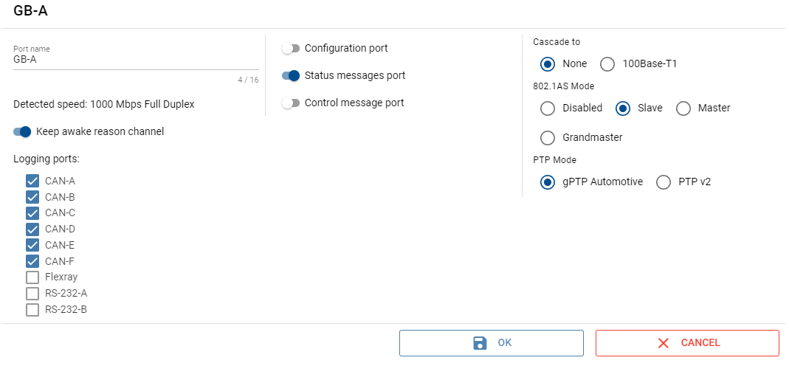

Figure 24 CM CAN GBA port web configuration view

1. CAN-A:
2. Port nameà GB-A
3. Interfaceà 660A
4. CAN Type à ISO CAN-FD
5. CAN Nodeà Active Node

please refer to the following figure for more information.

Figure 25 CM CAN channel web configuration view

1. Similar configuration can be done for all channels (individual ports of CAN Combo): 660B, 660C, 660D.
2. Apply configuration & save.

### CM 1000 HMTD

1. CM 1000 HMTD (10.104.3.144) should have the latest firmware updated on the module.

please refer to the following figure for more information.

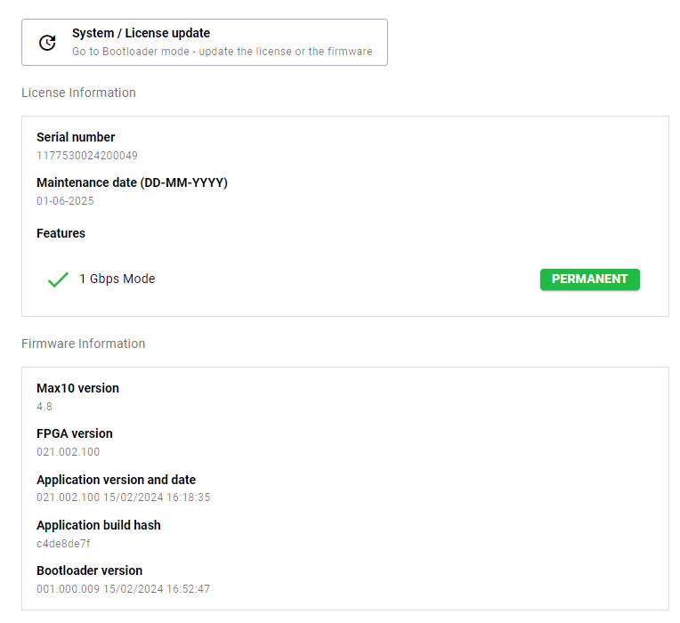

Figure 26 CM 1000 high HMTD system information view

1. The basic configuration for module is the port GB-b should be set to 1000Base T1-A.

Figure 27 CM 1000 high HMTD GB-B web configuration view

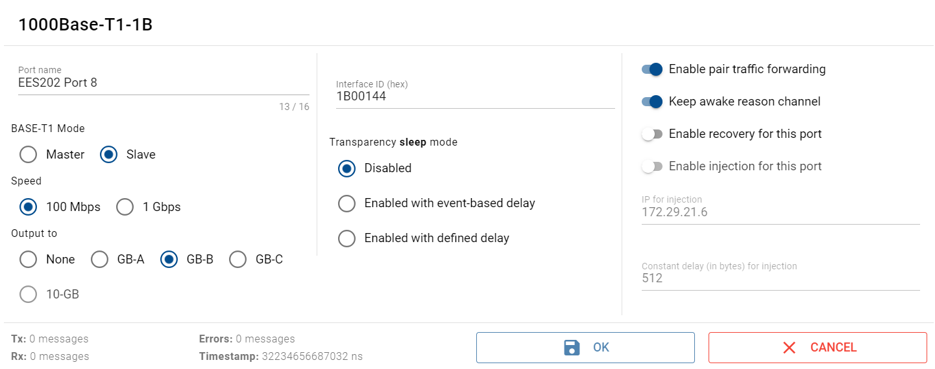

Figure 28 CM 1000 high HMTD B channel web configuration view

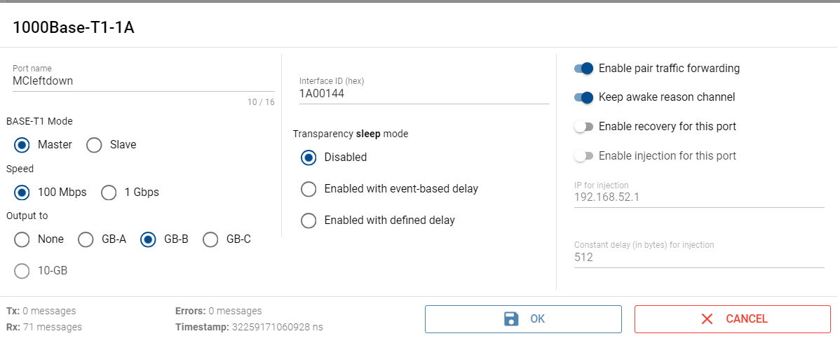

Figure 29 CM 1000 high HMTD A channel web configuration view

1. Apply configuration & Save will enable all the ports.

## 4.4 Validation checklist

* Ensured the Technica modules have the latest firmware flashed.
* Ensured the Technica modules have the CAN license installed.
* Is web interface configuration done for EES, CAN & CM 1000.

# 5. Test bench troubleshooting

When using the test bench, the following are the most common and frequent problems that may occur. Below are mentioned steps helps to resolve those problems to ensure the smooth working of the test bench.

Devices used on Test Bench:

* CAN COMBO
* EES
* CM1000

|  |  |  |  |
| --- | --- | --- | --- |
| **Sr No** | **Issue Faced** | **Devices** | **Troubleshooting** |
| 1 | Web Interface page not working | CAN COMBO | Check the Ip address of the Ethernet connected to PC from Enhanced Ethernet Switch 200, it should be 10.104.3. XX.  **Error! Reference source not found.** |
| Check the arrow of rotary switch of CAN-COMBO.  **Error! Reference source not found.** |
| Check the ethernet cable between EES and CAN-COMBO (Light should blink at both ends).  **Error! Reference source not found.**  **Error! Reference source not found.** |
| EES | Check the Default IP address of EES, if it is 10.0.0.200 then change the ip address.  **Error! Reference source not found.** |
| Set the IP address off Enhanced Ethernet Switch to 10.104.3.200- Logging, 10.104.3.201 - stimulation. |
| Check the Ethernet cable as it should properly connected to the PC. |
| 2 | RX-TX are not working | CAN COMBO | Check if web interface is working or not if not then follow Sr No 1 step. |
| Check the CAN wiring Harness and try with resistor at PT4 connector or direct connecting resistor wires at CAN-COMBO channels.  **Error! Reference source not found.** |
| Check if the latest firmware is flashed or not.  **Error! Reference source not found.** |
| If RX and TX are not working then remove EES connection and directly check the communication between two CAN COMBOS, if it is working then EES need to be troubleshoot. |
| EES | EES point need to check in office (gptp). |
| Grandmaster point (EES)- check in office. |
| Check if the latest firmware is flashed or not.  **Error! Reference source not found.** |
| 3 | OTHER | EES | if all the lights are not blinking and constant then power off the EES and restart it after 10sec. |

Table 11 Test bench troubleshooting steps

# 6. Maintenance

# For maintenance of the Test bench, please contact with your problem description to following points of contact.

[Niladri.Mandal@kpit.com](mailto:Niladri.Mandal@kpit.com)

[Suraj.Sutar@kpit.com](mailto:Suraj.Sutar@kpit.com)

# Note: We are in the process of creating a dedicated support email and will update the manual once it is ready.

## 6.1 Support for Test bench TYPE-B

For assistance with the test bench, if the test bench issues are not resolved by troubleshooting points mentioned above, our support team can access the test bench and provide the support.

# 7. Reference documents

Reference documents used for creating this user manual.

|  |  |
| --- | --- |
| Sr. No. | Title |
| 1 | <https://www.technica-engineering.com/products-and-tools/> |
| 2 | E&E_Network_Architecture_to_KPIT_r3 |
| 3 | Gen3_ECU_connector_pin_r1 |
| 4 | JA_EN_Area ECU Center端配_20240806_KPIT |
| 5 | Area ECU Centerシステム図_20231211_KPIT向け |
| 6 | Technica Modules Specification documents |

Table 12 Reference documents